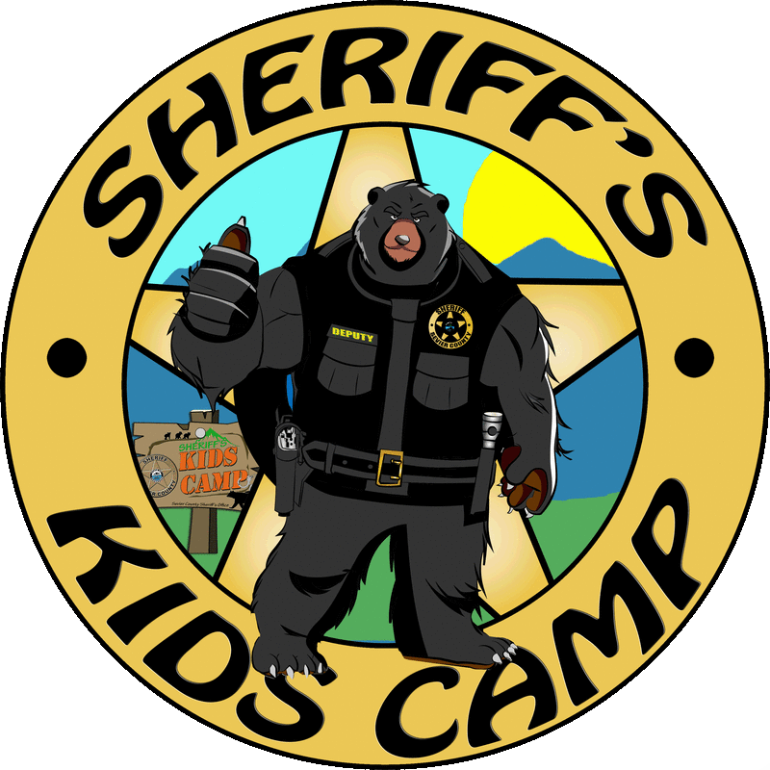
Sevier County Sheriff’s Office
2023
Kids Camp Application
Childs Information
Name:____________________________ Date of Birth:__________ Age:_______ Gender: Male / Female
Address:_______________________________________________
City:______________________________ Zip:_________________
Phone:____________________________
T-Shirt Size: S M L XL -----Adult or Youth (specify adult or youth when giving size)
Grade Level (This Fall):_____What school does your child attend?_______________________________________
Parent / Guardian Information
Mother / Guardian: _____________________________________ Day Phone:_______________________
E-mail Address:_________________________________________ Cell Phone:_______________________
Father / Guardian:_______________________________________ Day Phone:_______________________
E-mail Address:__________________________________________ Cell Phone:_______________________
Emergency Contact Information (other than names listed above)
Name:_____________________________________________ Phone:_____________________
Name:_____________________________________________ Phone:_____________________
Authorized Pick-Up Individuals (anyone not listed authorized to pick up your child before, after or during camp)
Name:__________________________________________ Phone:_______________________
Name:__________________________________________ Phone:_______________________
Name:__________________________________________ Phone:_______________________
Name:__________________________________________ Phone:_______________________
ACKNOWLEDGMENT OF RISK / HOLD HARMLESS

Sevier County Sheriff’s Office is pleased to offer to the community an opportunity for children to
experience high quality recreational experiences, and to form positive relationships with law enforcement officers through the “Sheriff’s Kids Camp” program. The Sheriff’s Office is committed to providing a positive experience with highly qualified and trained staff who are knowledgeable in the instruction and supervision of children in various activities offered through “Sheriff’s Kids Camp.”
This camp is only available to citizens of Sevier County.
Inherent in such activities is also the possible risk of injury. We ask that you read and sign the following
Hold Harmless Agreement as part of our registration process.
Acknowledgement of Risk:
I have voluntarily chosen to allow my child to attend “Sheriff’s Kids Camp” and I understand the risks involved. I recognize that Kids Camp and its activities like hiking, open recreation, aquatic activities, games/sports, zip lining, and rappelling may involve risk of injury to my child and I agree to accept any and all risks associated with it.
I hereby grant permission to the Sevier County Sheriff's Office and its employees to transport my child, via bus, van, or county vehicle on any scheduled field trips. Trips may include bus transportation to and from local attractions, the Great Smoky National Park, or other areas surrounding Sevier County.
Hold Harmless:
In consideration of allowing my child to participate in Kids Camp and to the fullest extent permitted by law, I agree to hold harmless the Sevier County Sheriff's Office and their officers, employees, staff and volunteers from and against all claims arising out of or resulting from my child’s participation in Kids Camp. “Claim” as used in this agreement means any financial loss, claim, suit, action, damage, or expense, including but not limited to attorney’s fees, attributable to bodily injury, sickness, disease or death, or injury to or destruction of tangible property including loss of use resulting therefrom. In addition, I hereby voluntarily hold harmless the Sevier County Sheriff’s Office and their officers, employees, staff, and volunteers from any and all claims, both present and future, that may be made by my child, me, my family, estate or heirs.
I hereby expressly agree to hold harmless the Sevier County Sheriff's Office, their officers, employees, staff and volunteers for any claim arising out of or incident to my child’s participation in Kids Camp, unless caused by the direct and sole negligence or willful misconduct of any of the above.
I understand that, although there will be emergency medical personnel available for the duration of Kids Camp, there are no facilities to care for ill children. I agree to keep myself readily accessible to pick up my child immediately when notified by Kids Camp staff that my child is ill and can no longer participate in Kids Camp

I have read and understand this Acknowledgement of Risk and Hold Harmless.
Parent / Guardian: Please Read Carefully & Sign Below
Child’s Name (Please Print): ____________________________________________
Name of Parent / Guardian (Signature): ___________________________________

PARTICIPATION PERMISSIONS
Child Will Abide By Rules & Regulations:
My child agrees to abide by all Kids Camp regulations while attending Kids Camp and will comply with all Kids Camp staff instructions. My child understands that violation of the rules and regulations is grounds for immediate dismissal from Kids Camp. Furthermore, any illegal activity such as weapons, drugs, alcohol or violence will be dealt with on a criminal level as well.
Signature of Child: ________________________
Signature of Parent/Guardian: ____________________________

____________________________________________________________________________________________

Permission to Use Photograph or Likeness:
I hereby give permission to the Sevier County Sheriff's Office to use my child’s photographic or video image, in whole or in part, for Kids Camp specific public information and marketing activities at the discretion of Sevier County Sheriff’s Office.
Signature of Parent / Guardian: _________________________

____________________________________________________________________________________________

Permission to Participate in Field Trip Events:
I am hereby giving permission for my child to be transported and participate in all field trips to area attractions. I understand these events will be heavily staffed and overseen by fulltime sheriff’s deputies, reserve deputies, and volunteers.
Signature of Parent / Guardian: _________________________

____________________________________________________________________________________________
Permission to Participate in Water Events:
I hereby give permission for my child to participate swimming in the pool, tubing, rafting, etc.
Signature of Parent / Guardian: _________________________
Sevier County Sheriff’s Department
“KIDS CAMP” REGISTRATION INFORMATION

** THE FOLLOWING DONATIONS WILL BE GLADLY ACCEPTED**

- SUNSCREEN
- INSECT-BUG SPRAY
- HAND SANITIZER
- BOTTLED WATERS, Flavored Water, Etc…
- GATORADE MIX
- SNACKS
- BAND-AIDS
- CLOROX WIPES

Important Information

(Detach & Keep This Paper)
Registration Checklist: (check this prior to sending application)
- Registration application is COMPLETELY filled out.
- All areas that the camper must sign are completed and signed.
- All areas that the parent / guardian must sign are completed and signed.
- Application must be sent to the address on the bottom of this page or hand delivered.
What you need to know AFTER your application is sent:
You will be notified by mail, email, or phone call after your application has been received and reviewed.
If you know in advance that your child will be absent from Kids Camp, please notify us immediately so that we may put someone in their place. Once all applications have been submitted, 35 children will be selected to attend the camp. Your acceptance letter will detail the items that your child will need to bring and also a list of items that your child will not be allowed to bring.

Sevier County Sheriff’s Office Kids Camp 2023
July 24-28, 2023
Return completed applications to:
SCSO Office of Community Relations
C/O Sergeant Megan Gamble
735 Middle Creek Road Sevierville, TN 37862
For more information on Kids Camp log on to: www.Seviercountysheriff.com

